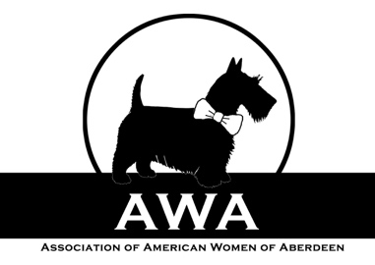
FOR BOARD USE ONLY
CLASSIFICATION*:
Active ______ Associate _____
*See By-Laws Article below for details.

PAYMENT RECEIVED:
 Cash  Check  Bank Transfer  Paypal

_________________________________________________________________________________________________________________________
ASSOCIATION OF AMERICAN WOMEN OF ABERDEEN
MEMBERSHIP APPLICATION 2018-2019

 Check this box if you are a RENEWING member |  Check this box if you are a NEW member
MEMBER INFORMATION (Please print):
Last Name: ________________________________________ | First Name: ________________________________________
Mobile #:__________________________________________ | Email: _____________________________________________
Address:___________________________________________ | Birth Month: __________ Birth Day: __________________
Area: _____________________________________________ | Post Code: ___________________________
Citizenship (check all that apply):  US  Canada  UK  Other___________________________________
Profession and/or Employer: ________________________________________________________________________________ Trades/skills/talents that would be willing to share with the club: __________________________________________________________________________________________________________
OPTIONAL (Please print):
Partner’s Name:__________________________________ Profession and/or employer:__________________________
Partner’s Citizenship: US________ Canada________ UK________ Other________________
Children’s names/ages: ______________________________________________________________________________________

Personal Data Preferences:
 Check this box if you consent to receive emails from AWA about 1-2 per month containing the monthly newsletter and other important association information. If you do not check this box, we will not be able to email you according to the EU regulation GDPR

Check this box if you consent to your information as given above to be included in the Membership Directory. This directory is emailed out once per year and posted in the Facebook group. It is available only to Members.

______________________________________________________________ ____________________________
Signature of Applicant Date

*BY-LAWS ARTICLE-MEMBERSHIP: ACTIVE membership shall be open to persons who are United States citizens. A person, not eligible for ACTIVE membership may apply for ASSOCIATE membership. ASSOCIATE members pay dues, participate in AWA activities and have the right to vote. Classification is for FAWCO membership purposes and does not impact member benefits.

Payment can be made by check payable to “AWA” & posted to AWA, PO BOX 11952, Westhill AB13 0BW.
We also accept direct bank transfer and Paypal payments. Please contact membership@awaaberdeen.org for the club Paypal link/banking details or for any additional membership queries.

